TM: Which CI to which target?

Table of Contents

Requirements 2

Introduction 2

Routing 2

Simple CI Routing 2

TechnicalProductInstance Routing 2

TechnicalProduct Routing 3

Data Augmentation 3

HP-Managed Propogation 3

Computer System 3

Business Rules 4

General 4

ComputerSystem 4

**Modification History**

|  |  |  |
| --- | --- | --- |
| Date | Who | Why |
| 20120126 | Dirk Vermeylen | Initial version to resolve bug 165 |
| 20120131 | Kevin Simpson | Updates following discussion |
| 20120202 | Kevin Simpson | Updates following discussion – stable version. |
| 20120215 | Kevin Simpson | Updates following comment 31 on bug 165 |
| 20120217 | Kevin Simpson | Re-write following discussion |
| 20120309 | Kevin Simpson | Change in requirement for CS with billing code “45”, see bug 308. |
| 20120312 | Kevin Simpson | Bug 297 step 4 change. |
| 20120727 | Kevin Simpson | Default HP-Owned and HP-Managed if UNKNOWN and the source is ESL-ALU*. |

# Requirements

See the following document for all background information:

[https:/vcs-java.elabs.eds.com:2403/svn/alucmdb/artifacts/trunk/analysisdeliverables/sourceprep/Master%20System%20of%20a%20CI%20FULL.docx](https://vcs-java.elabs.eds.com:2403/svn/alucmdb/artifacts/trunk/analysisdeliverables/sourceprep/Master%20System%20of%20a%20CI%20FULL.docx)

# Introduction

Master of a CI is defined based on the interpretation of one of two Boolean values depending on the type of Transformation Model Component being processed.

# Routing

### Simple CI Routing

The following tables indicate the required export routing for each Transformation Model Component.

|  |  |  |  |  |
| --- | --- | --- | --- | --- |
|  | HP-Managed | | | |
| True | False | UNKNOWN | Consistency Check Reqd? |
| Hardware | Do not export | Do not export | Invalid - Fatal | Yes |
| Computer System | ESL Sub-business (System) | uCMDB  (Technical: Host Node) | Invalid - Fatal | Yes * |
| Application | Do not export | Do not export | Invalid - Fatal | Yes |
| Technical Product Instance | ESL Sub-business (Instance) | uCMDB (Technical: SW_Element) | Invalid - Fatal | Yes |

* See exception for ComputerSystems with billing code “45”.

### TechnicalProductInstance Routing

The TechnicalProductInstance is the only Component that relies upon both HP-Managed and HP-Owned attributes. For both attributes the consistency check is required, and in all cases the “UNKNOWN” value is invalid (Fatal).

|  |  |  |  |  |
| --- | --- | --- | --- | --- |
|  | | HP-Managed | | |
| True | False | UNKNOWN |
| HP Owned | True | Do not export | Do not export | Invalid - Fatal |
| False | ESL Sub-business (System) | uCMDB  (Technical: Host Node) | Invalid - Fatal |
| UNKNOWN | Invalid - Fatal | Invalid - Fatal | Invalid - Fatal |

### TechnicalProduct Routing

As a Technical Product can be known in several CMDBs at the same time and the instances thereof can be owned by different parties. To decide where a TechnicalProduct should be exported we have to look at the InstalledProducts of this TechnicalProduct and based on these relationships export the TechnicalProduct.

Therefore it is the CD-Product-InstalledProduct relationships associated with a single TechnicalProduct must be exported, the net result will appear that a single TechnicalProduct can be exported to multiple targets.

This can only be established once the TechnicalProductInstances have been evaluated.

|  |  |  |  |  |
| --- | --- | --- | --- | --- |
|  | HP-Managed | | | |
|  | True | False | UNKNOWN | Consistency Check Reqd? |
| CD-Product-InstalledProduct. InstalledProduct | ~~ESL~~ ~~(Solution)~~ | uCMDB (Do not export) | Invalid - Fatal | Yes |

BUG297: No Technical Solutions should be attempted to be inserted into ESL. This is a manual effort at ESL and requires data validation and a lengthy timeline to achieve this.   
Any Technical Solution that REQUIRES to be exported to ESL should be exported to an error-report, this will be achieved by the standard export/mapping mechanism.

## ConsistencyChecks

ConsistencyChecks will be evaluated based on the following structure:  
Everything under the relationship to the TechnicalProduct has to be consistent*, but the value HP-Managed will dictate where the relationship is exported to.

* ComputerSystem with resourceUnitCode 45: In a complete chain of HP-Managed=FALSE, it ***IS*** allowed to have the ComputerSystem HP-Managed=TRUE but only if its resourceUnitCode is “45”.  
These ComputerSystems are provided by HP to the client so they can install and execute whatever they want to. These ComputerSystems are also supported outside of the official SLA processes.

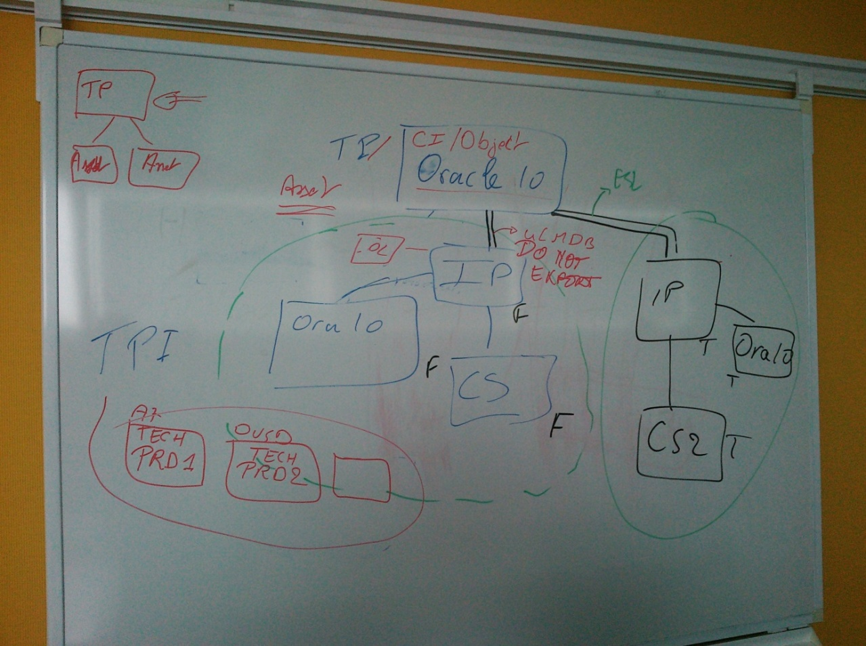

# Data Augmentation

### HP-Managed Propogation

In order to solve data issues related to source systems not being able to provide the required HP-Managed information, a specific Data Augmentation is required that can only be realised within the Transformation Application.

Comment 25 on bug 165 details the decision made in this area.

DIRK: If ComputerSystem resourceUnitCode=”45” we set HP-Managed to true (see below) but is it valid to propagate this value further up the chain? I do not think so. I think that the propogation further up the chain from such a ComputerSystem propagates FALSE where the value is currently UNKNOWN.

It is not allowed to propagate the HP-Managed value (TRUE) from the Computersystem (RU Code 45) further up the Chain.

If a CI comes from ESL (ESL-CMO) we CANNOT simply set HP-Managed and HP-Owned to TRUE as a default as the data is ESL-CMO is possible in error. For any other ESL source we can.

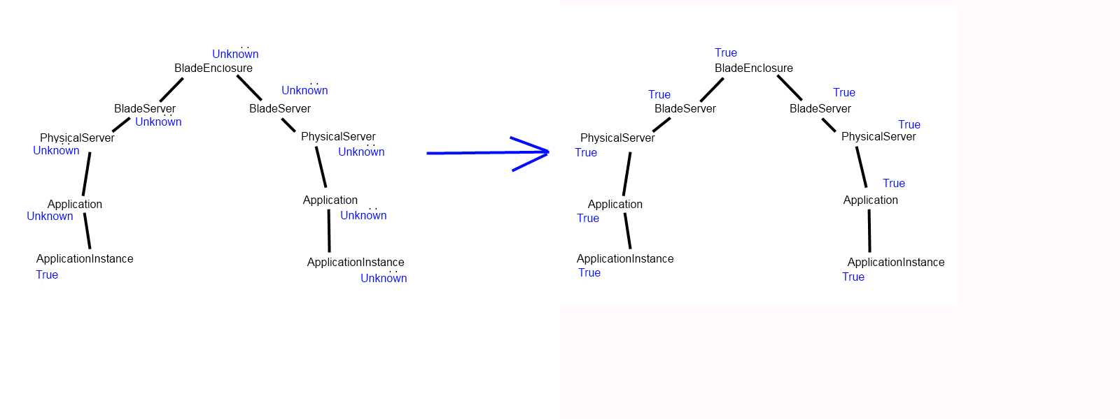

### Computer System

REQUIREMENT:

If HP-Managed=false  
And ComputerSystem.Billing_ResourceUnit_code = ’45 - %’  
THEN HP_Managed=true

Reason: this is Hosting Platform that needs to be managed in ESL.

# Business Rules

### General

1. The whole chain, from Application / Product to Hardware needs to be **managed** by a single party irrespective of the party, and irrespective of who owns it (if applicable for the Component type).

Examples that are **not** allowed:

* ComputerSystem (billing code not “45”) = ALU Managed  
  Database Instance = HP Managed  
  Application = ALU Managed
* On same Farm/Cluster, some Virtual Guests are ALU Managed while others are HP Managed

Exception : 09/07/2012 Bug 645 :

The whole chain, from Application/ product to hardware needs to be managed by a single party, with the exception for applications that are linked to a Computersystem. This requirement change, makes it possible that an applicationInstance (HPMananged = false) is running on a Computersystem (ex. clusterPackage) that is (HPManaged = True). This exception in the HPManaged chain applies to a CS only !

For the HPmanaged chain towards products, there is NO change at the moment.

2. Attribute Overwriting: For attributes HP-Owned or HP-Managed do not define any overwrite rules as no value from ESL may be used to replace the values from A7 or OVSD.

### ComputerSystem

If HP-Managed=false  
THEN ComputerSystem.Billing_ResourceUnit_code MUST NOT BE VALID Billing Code except “0C – *”

NOTE:  
BillingCode format: Hexadecimal-character + “ “ + “-“ + anything.  
REASON: Incorrect data at source.